Pokhara University

Level: Bachelor | Semester – Fall | Year : 2009
Programme: BE |  | Full Marks : 100
Course: Engineering Mathematics III |  | Time : 3hrs.

Candidates are required to give their answers in their own words as far as practicable.
The figures in the margin indicate full marks.

Attempt all the questions.

1. | - Define transpose of a matrix. Show that (AB)^{t} = B^{t} A^{t}, where A and B are two matrices of specific order.  OR  Using the properties of determinant, Show that 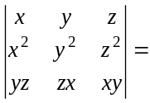.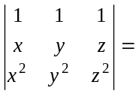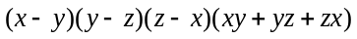  - Solve the system of linear equations: 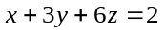, 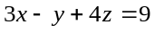,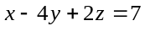, by Gauss elimination methods. | 8  7
2. | - Define basis of a vector space over the field. Check the following vectors form a basis of R³.(1,1,1),(1,23,2), (-1,0,1).  - Determine the eigen values and eigen vectors of the matrix. 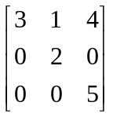 | 7  8
3. | - A particle moves on the curve x = t³+1, y = t², z = 2t+5 where t is the time. Find the component of velocity and acceleration at t = 1 in the direction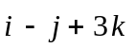.  - Define Divergence and Curl of a vector. If 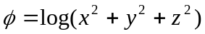find div (grad ) and curl (grad ). | 8  7
4. | - Evaluate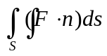, where 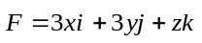, and S be the part of the surface 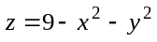, with 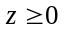.  - State Stokes theorem. Evaluate 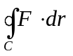, where 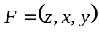, S : the hemisphere 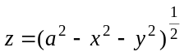. | 7  8
5. | - State and prove D’ Alemberts ratio test series .  - Find the interval of convergence of an infinite series 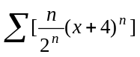. | 7  8
6. | - Write the Fourier coefficients of a function f(x). find the Fourier expansion of the function f(x) = x+|x| (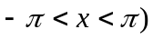.  - Find the Fourier cosine as well as Fourier sine series of the function f(x) = x² if 0<x<1. | 7  8
7. | Solve the followings:  - 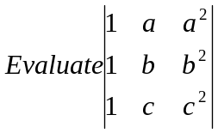  - Test the convergence and divergence of series 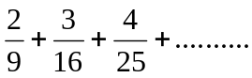  - Check even, odd or neither of 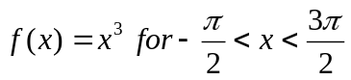.  - Check exactness condition under the integral sign 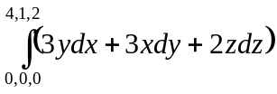and evaluate.  - Find the directional derivative of f at P in the direction of where. | 5×2

